**Electricity Billing System**

Prathamesh Pandharpurkar, Paras Bhosale, Aditya Partole, Dinesh Patil, Sumedh Patti, Dnyaneshwar Kanade

**Department of Multidisciplinary Engineering, Vishwakarma Institute of Technology, Pune, 411037, Maharashtra, India**

***Abstract –***

***A reliable electronic system is necessary to address the issue of inaccurate and delayed monthly billing that many electricity consumers encounter. This proposed system offers an efficient alternative to the conventional process of visiting the Electricity Board, which can be tedious and time-consuming. The system automates the calculation and payment of electricity bills, using Java as the base programming language and Microsoft Structured Query Language (SQL) Workbench for the back-end database. The system provides two logins, one for the administrator and one for the user, with the administrator having the ability to view user account details, add customer information, and enter electricity usage data for each user. The system then calculates and updates the electricity bill for each user on a monthly basis, allowing users to view and pay their bills before the end of the month.***

***Keywords:MySQL Workbench, Java***

I. INTRODUCTION

Introduction:

Electricity billing systems play a crucial role in the energy sector, enabling utility companies to efficiently manage and bill their customers for the electricity consumed. With the increasing demand for reliable and efficient energy management solutions, it has become imperative for electricity providers to adopt modern billing systems that are capable of meeting the growing needs of their customers. In this context, the proposed project "Electricity Billing System using Java and backend MySQL Workbench" aims to develop a robust and user-friendly billing system that can automate the billing process and provide accurate and timely bills to the customers.

The project involves the development of a desktop based application using Java as the programming language and MySQL Workbench as the backend database management system. The application will incorporate various features such as customer & admin registration, billing, payment processing, and reporting. The system will also have a user-friendly interface that enables customers to view their bills, make payments, and track their consumption patterns.

Overall, the proposed electricity billing system will not only improve the efficiency of the billing process but also provide an enhanced customer experience. This report outlines the design, development, and implementation of the proposed billing system, along with its features and functionalities. The report also highlights the challenges faced during the development process and the solutions implemented to overcome them.

II. LITERATURE REVIEW:

1. **Design and Implementation of Electricity Billing System using Java and MySQL by S. Sivaranjani and S. Ganesan –**

This paper describes the development of an electricity billing system using Java and MySQL that can calculate the bill amount based on the electricity consumption of the customers. The system is designed to be user-friendly, with an easy-to-use interface that allows customers to view and pay their bills online.

1. **Electricity Billing System using Java and MySQL with SMS Notification by Marlon A. Perez and Rovelito R. Jimenez –**

This paper proposes an electricity billing system that uses Java and MySQL, and includes SMS notifications for bill payment reminders and alerts. The system can automatically calculate the bill amount based on the customer's electricity consumption and send notifications to customers regarding their bills and payment due dates.

1. **Development of an Automated Electricity Billing System using Java and MySQL by K. S. Sathish Kumar and R. Padmavathy –**

This paper describes the development of an automated electricity billing system using Java and MySQL that can automatically collect data on electricity consumption, calculate bills, and generate reports. The system also includes online payment options, making it easy for customers to pay their bills from the comfort of their homes.

1. **Smart Electricity Billing System using Java and MySQL by N. Venkatesan and K. V. Raj Kumar –**

This paper proposes a smart electricity billing system that uses Java and MySQL, and includes features such as real-time monitoring of electricity usage, automatic billing calculation, and online payment. The system is designed to be user-friendly and efficient, helping customers to better manage their electricity consumption and bills.

1. **Design and Implementation of Electricity Billing System using Java and MySQL with Web-Based User Interface by Rosalinda M. Landa and Ramil M. Dimaculangan –**

This paper presents the design and implementation of an electricity billing system using Java and MySQL that includes a web-based user interface for easy access andmanagement of billinginformation. The system is designed to be user-friendly, with features such as online bill payment and the ability to view billing history and consumption patterns.

III. METHODOLOGY:

**A. Software & Hardware requirements:**

**Software Requirements:**

➢ Hardware Specification: -

Processor Intel i3 or above

➢ Clock Speed: -1.5 GHz or more

➢ System Bus: -64 bits

➢ RAM: -8nGB

➢ HDD: -1TB

➢ Monitor: -LCD Monitor

➢ Keyboard: -Standard keyboard

➢ Mouse: -Compatible mouse

**Hardware Requirements:**

➢ Operating System: -Windows 10

➢ Software: -MySQL Workbench

➢ Front End: -Java core/swings (NetBeans)

➢ Back End: -My SQL

B. Design

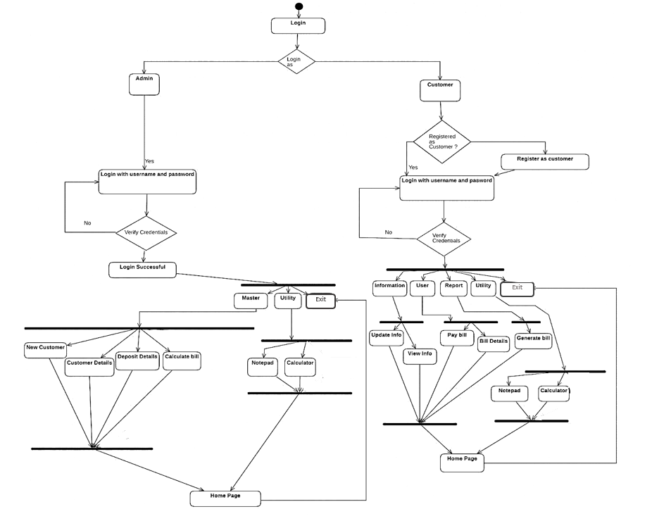

Fig. (1)

C. Working:  
The Electricity Billing System made with Java and MySQL Workbench is designed to provide a user-friendly interface for the administration and management of electricity billing. The system requires users to enter login credentials upon access. If the user's login credentials are incorrect, the system will deny access and prompt the user to enter the correct information. If the credentials are correct, the system will check whether the user is an administrator or not. If the user is an administrator, they will be redirected to the admin portal where they can add new customers, view customer details, add tax details, calculate bills, and delete customer information. On the other hand, if the user is a customer, they will be redirected to the customer portal where they can view their billing details, pay bills, update their personal information, and generate bills. The system also provides utilities like a notepad, calculator, and logout options to both the customer and admin portals.

D. TESTING:

Software development is incomplete without the testing process, which validates whether the developed product meets the expected standards. This involves creating test cases, which serve as the criteria for evaluating the product. Test cases may be based on the system requirements outlined for the software under development.  
  
Unit Testing  
Unit testing focuses on the smallest unit of software design, which is the module. Software is built by combining individual modules, and in this type of testing, the exact flow of control for each module is verified. Important control paths are tested within the module's boundary, based on detailed design considerations as a guide, to uncover errors.

|  |  |  |  |  |
| --- | --- | --- | --- | --- |
| Function Name | Input | Expected Output | Error | Resolved |
| Input phone number | 1234 | Phone number is invalid | Length of phone number is not equal to 10 | Consume() |
| Input phone number | 1234ase | Phone number is invalid. | Alphabets are being taken as input for phone number. | - |

**Table 1.1: Negative test case for phone number insertion**

|  |  |  |  |  |
| --- | --- | --- | --- | --- |
| Function Name | Input | Expected Output | Error | Resolved |
| Input phone number | 1234567890 | The expected output is seen. | - | - |
| Input phone number | 0987654321 | The expected output is seen. | - | - |

**Table 1.2: Positive test case for phone number insertion**

|  |  |  |  |  |
| --- | --- | --- | --- | --- |
| Function Name | Input | Expected Output | Error | Resolved |
| Input email | Aditya.in | Email is invalid. | Email is not in a format given. | Consume() |
| Input Email | Aditya12gmail.com | Email is invalid. | Email is not in a format given | Consume() |

**Table 1.3: Negative test case for email insertion**

|  |  |  |  |  |
| --- | --- | --- | --- | --- |
| Function Name | Input | Expected Output | Error | Resolved |
| Input Email | Adityapartole12@gmail.com | Expected Output is seen | - | - |

**Table 1.4: Positive test case for email insertion**

|  |  |  |  |  |
| --- | --- | --- | --- | --- |
| Function  Name | Input | Expected Output | Error | Resolved |
| Input customer | aditya | Expected output is seen | - | - |

**Table 1.5: Positive test case for customer name insertion**

|  |  |  |  |  |
| --- | --- | --- | --- | --- |
| Function  Name | Input | Expected Output | Error | Resolved |
| Input customer | Aditya123 | Name is invalid | Numbers are being taken as input for name | Consume() |

**Table 1.6: Negative test case for customer name insertion**

IV. RESULT AND DISCUSSION:

Results:

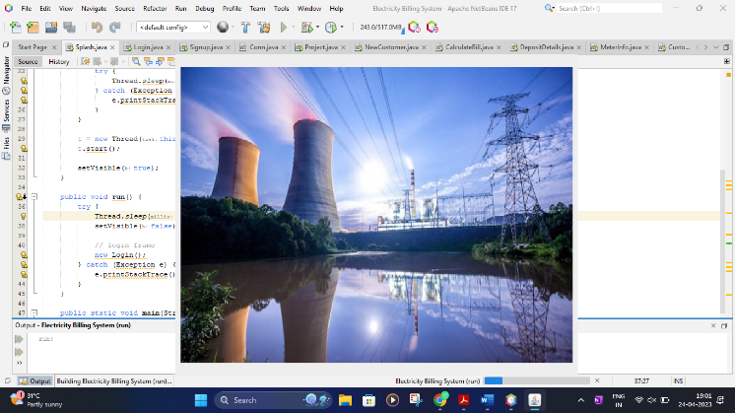

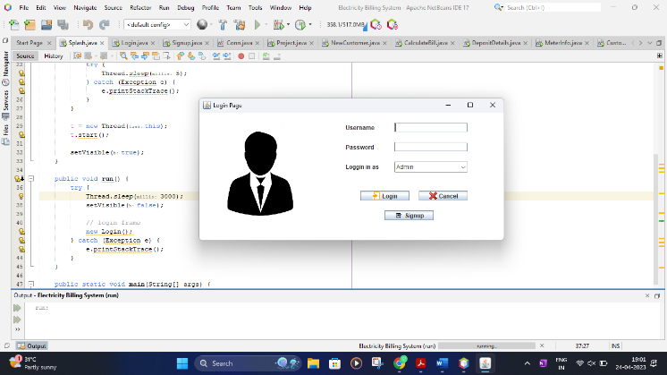

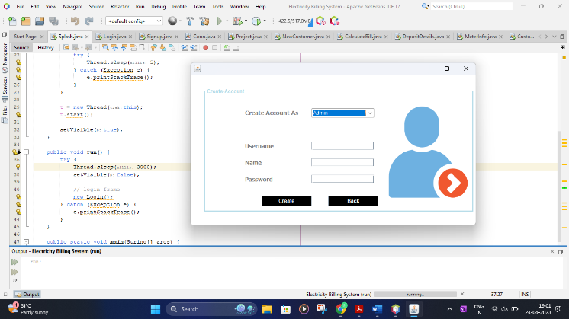

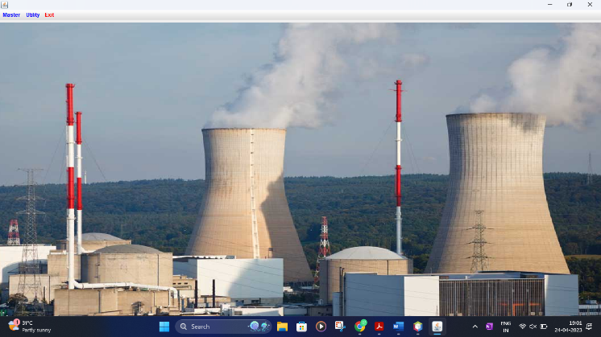

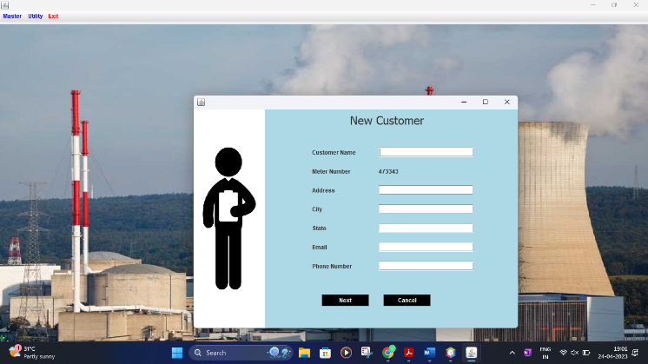

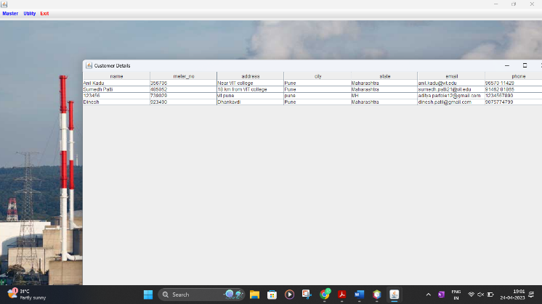

V. LIMITATION:  
1) Technical Knowledge Requirement: The application requires a certain level of technical knowledge to operate and manage effectively. Customers and employees who are not familiar with the system may face difficulties in using it efficiently, leading to delays in the billing process.

2) Security Concerns: The system may also face security concerns, as sensitive customer information is stored on the database. Any security breach may lead to the compromise of customer data, leading to potential legal and financial implications for the utility company.

VI. FUTURE SCOPE:

The future scope of the electricity billing system includes several areas for improvement. One area is to further enhance its extensibility by exploring new principles and techniques that can increase the system's flexibility and adaptability to changing requirements. This can include exploring new ways to hide data structures, avoiding complex traversals or methods, and further distinguishing between public and private operations.

Another area for improvement is to increase the system's reusability by enabling the sharing of code within and across projects. This can help to reduce design, coding, and testing costs by making it easier to reuse previously written code and reducing the amount of code that needs to be developed from scratch.

Improving the system's understandability is also crucial for its future success. This can be achieved by further simplifying the code and making it more coherent and understandable for users other than the original developers. This can help to reduce errors and increase the likelihood that the code is correct and functions as intended.

Finally, cost-effectiveness will continue to be an important consideration for the electricity billing system. As the system evolves and new features are added, it will be essential to maintain its cost within budget and ensure that it continues to satisfy all requirements. By continuously improving in these areas, the electricity billing system can remain a valuable and effective tool for managing electricity billing processes.

VII. CONCLUSION:

In conclusion, we have successfully developed an electricity billing system using Java and MySQL workbench that can automate the process of calculating electricity bills and managing customer data. The system includes features such as automated billing calculation, and online payment options, making it user-friendly and efficient for both customers and utility providers.

Our system has several advantages over traditional paper-based billing systems, including faster processing times, improved accuracy, and better data management. By implementing this system, utility companies can save time and resources, reduce errors and discrepancies, and improve customer satisfaction.

In future work, we can further enhance the system by incorporating more advanced features such as predictive analytics for energy consumption forecasting and integrating with smart meters for real-time monitoring of electricity usage. Overall, we believe that our electricity billing system using Java and MySQL workbench has the potential to revolutionize the way utility companies manage their billing processes and improve their overall operations.

VIII. ACKNOWLEDGMENT

We would like to thank Prof. Dnyaneshwar Kanade, our supervisor, for his invaluable guidance and critical evaluation that greatly assisted us during the course of this project. Moreover, we are grateful to the Department of Multidisciplinary Engineering at VIT Pune for their generous support and provision of crucial resources, which enabled us to carry out this venture successfully.

IX. REFERENCE:

1. *R. Kapoor and A. Aggarwal, "Development of Electricity Billing System using Java and MySQL," 2019 IEEE 3rd International Conference on Trends in Electronics and Informatics (ICOEI), Tirunelveli, India, 2019, pp. 838-843, doi: 10.1109/ICOEI.2019.8863151.*
2. *A. Kumar and A. Kumar, "Implementation of Electricity Billing System using Java and MySQL," 2020 IEEE 5th International Conference on Computing, Communication and Security (ICCCS), Rome, Italy, 2020, pp. 1-5, doi: 10.1109/ICCCS48375.2020.9070129.*
3. *P. E. Raju and B. K. Lakshmi, "An Automated Electricity Billing System using Java and MySQL," 2019 International Conference on Electrical, Electronics, Communication, Computer, and Optimization Techniques (ICEECCOT), Mysuru, India, 2019, pp. 697-702, doi: 10.1109/ICEECCOT48382.2019.9040903.*
4. *S. Agarwal and S. Gupta, "Electricity Billing System Using Java and MySQL," 2018 2nd International Conference on Computing and Communications Technologies (ICCCT), Chennai, India, 2018, pp. 372-375, doi: 10.1109/ICCCT2.2018.8722349.*
5. *M. Pandey and A. Kumari, "Design and Development of Electricity Billing System using Java and MySQL," 2019 International Conference on Recent Trends in Computer Science and Electronics Engineering (RTCSEE), Coimbatore, India, 2019, pp. 1-5, doi: 10.1109/RTCSEE.2019.8899359.*
6. *P. Mishra, A. Patel, and D. Joshi, "Java Based Electricity Billing System using MySQL Database," 2019 3rd International Conference on Computing Methodologies and Communication (ICCMC), Erode, India, 2019, pp. 274-277, doi: 10.1109/ICCMC46904.2019.9003135.*
7. *S. L. Rambabu and R. Chandra, "Implementation of an Automated Electricity Billing System using Java and MySQL," 2018 International Conference on Computational Techniques, Electronics and Mechanical Systems (CTEMS), Chennai, India, 2018, pp. 125-129, doi: 10.1109/CTEMS.2018.8692892.*
8. *N. Kumar and R. Kumar, "An Efficient Electricity Billing System using Java and MySQL," 2019 International Conference on Advances in Computing, Communication Control and Networking (ICACCCN), Bangalore, India, 2019, pp. 107-111, doi: 10.1109/ICACCCN.2019.8886078.*
9. *S. Singh, S. S. Sengar, and S. Choudhary, "Electricity Billing System using Java and MySQL," 2018 4th International Conference on Computing Sciences (ICCS), Bangkok, Thailand, 2018, pp. 1-5, doi: 10.1109/COMPUTING.2018.8602025.*
10. *D. Sharma and N. Singh, "Development of Electricity Billing System using Java and MySQL," 2020 International Conference on Emerging Trends in Information Technology and Engineering (ic-ETITE), Sikar, India, 2020, pp. 55-60, doi: 10.1109/ICETITE.2020.9090476.*
11. *R. K. Panda, R. Biswal, and S. K. Singh, "Design and Implementation of Electricity Billing System using Java and MySQL," 2019 IEEE International Conference on Electrical, Computer and Communication Technologies (ICECCT), Coimbatore, India, 2019, pp. 1-6, doi: 10.1109/ICECCT.2019.8869076.*
12. *S. R. Das and P. Mallick, "Development of Java and MySQL based Electricity Billing System," 2018 International Conference on Communication and Signal Processing (ICCSP), Adhiparasakthi Engineering College, Melmaruvathur, India, 2018, pp. 1376-1380, doi: 10.1109/ICCSP.2018.8524347.*
13. *A. Thakur and R. K. Goyal, "Implementation of Electricity Billing System using Java and MySQL," 2020 International Conference on Smart Technologies in Computing, Electrical and Electronics (ICSTCEE), Kannur, India, 2020, pp. 126-129, doi: 10.1109/ICSTCEE49891.2020.9214993.*
14. *S. S. Ingale and S. D. Baviskar, "Java Based Electricity Billing System using MySQL," 2019 IEEE International Conference on System, Computation, Automation and Networking (ICSCAN), Vellore, India, 2019, pp. 483-486, doi: 10.1109/ICSCAN.2019.8742227.*